Relooping for Biochemistry Test Objective 3: Enzymes (4.1.3)
In the diagram below, label the following: enzyme, substrate, product, and active site.
- Which statement is correct?
- The enzyme was not affected (changed) during the reaction, but it cannot be used again.
- The enzyme was changed during the reaction and cannot be used again.
- The enzyme was not affected (changed) during the reaction, and it can be used again.

2) What could make this reaction even faster?

3) What would slow down this reaction?

4) If the substrate for the enzyme above is a starch, then what must the products be? __________________________________

5) If the substrate for the enzyme above is lactose, then what might be the name of this enzyme? ______________________ because enzymes are named after their substrate!

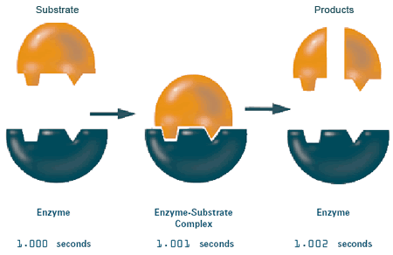

- How does temperature affect enzyme activity?
- Examine the graph to the right.
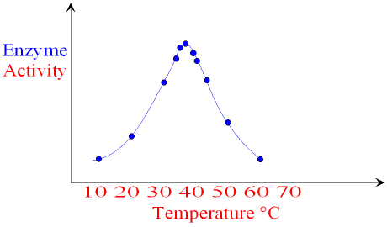

- At what temperature does the enzyme work best? ___________________ THIS IS CALLED ITS OPTIMAL TEMPERATURE.

- At what temperature does the enzyme not function properly? _____________ THIS IS CALLED DENATURING. Denaturing happens when the enzyme loses its shape (specifically at the Active Site) and can no longer work.

- Summarize what it means for an enzyme to denature: ____________________________ _____________________________
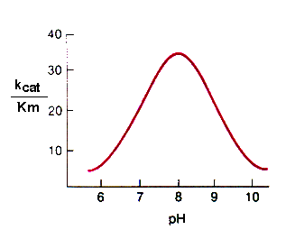
- How does pH affect enzyme function?
  - Analyze the 2nd graph to the right.

  - What is the optimum pH for this enzyme? _______

  - What will happen to this enzyme in an acidic environment? __________________________________________

