Relooping for Unit 2 Biochemistry Test Objective 2: Organic Molecules (4.1.1)

- These pictures are examples of _____________________ (carbohydrates, lipids, proteins, nucleic acids)

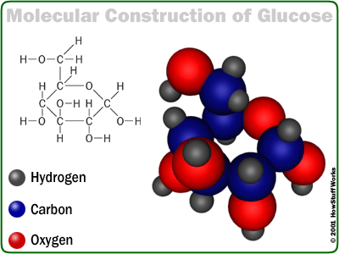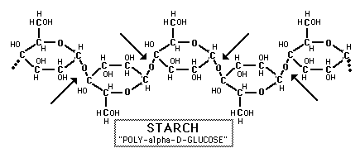
2. What elements (atoms) do they all have in common? ________________________

3. Examples of foods with this type of organic molecule: __________________________________ _________________________________________________________________________________________

4. Types:

- ____________________________ - major energy source produced by plants
- ____________________________ - source of stored energy in plants
- ____________________________ - stored energy in animals (stored in the liver!)
- ____________________________ - component of plant cell walls; indigestible by humans

4. Monomer units (building blocks): ______________________________ Draw one in the space below!

5. What is the main function of this organic molecule in living things? _______________________________________________________________________________________

6. Why is a starch or glycogen (B) molecule more complex than a glucose (A)? ____________________________________________________________________________________ What is another difference between the two? ___________________________________________ ________________________________________________________________________________________
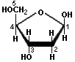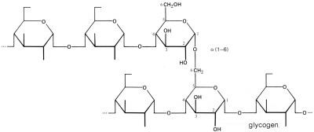
A B
- These are examples of: __________________________ (carbohydrates, lipids, proteins, nucleic acids)

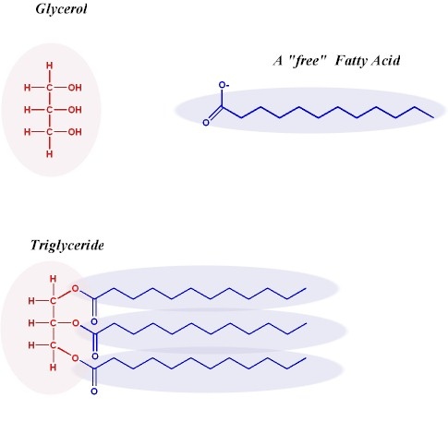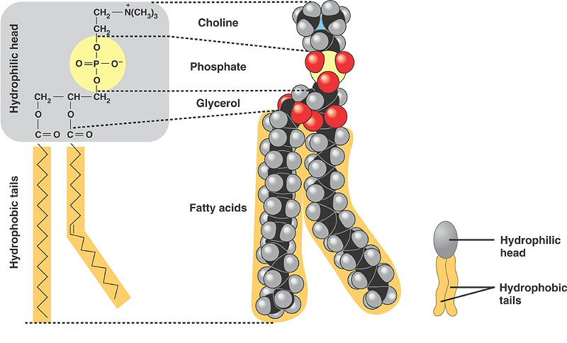

2. What elements (atoms) do they all have in common? __________________________________

3. Examples of foods with this organic molecule: __________________________________________

4. Types:

Phospholipids Oils Wax Fats

- ____________________________ - found in the cell membrane
- ____________________________ - found in fatty foods
- ____________________________ - component of vegetable oil
- ____________________________ - water-proof covering of some plants

4. Monomer units: ____________________________ and ___________________________.

5. List at least 3 functions of this organic molecule in living things:
  - _____________________________________________________
  - _____________________________________________________
  - _____________________________________________________

6. What do Lipids have in common with Carbohydrates?

7. Organic Compounds all contain the elements _______________ and ____________________ and are found in _______________________ things. Circle all the ORGANIC compounds below.

- Starch f. Simple Sugars k. water
- Oxygen g. Carbohydrates l. Enzymes
- CH4 h. Oxygen m. Fatty Acids
- Proteins i. Carbon dioxide n. Monosaccharides
- Insulin j. Amino Acids j. Nucleic Acids
- These are all examples of: _______________________________________ (carbohydrates, lipids, proteins, nucleic acids)
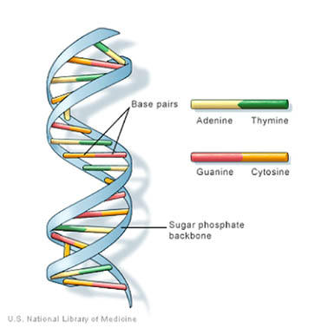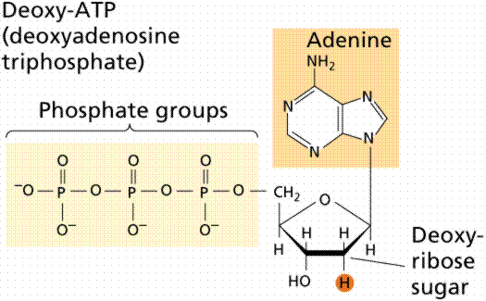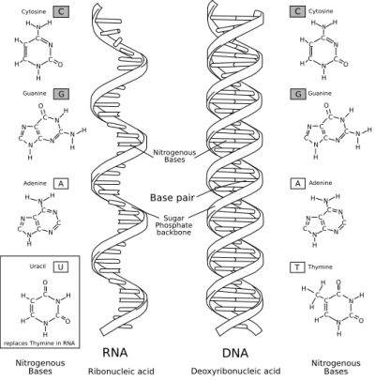

- What elements (atoms) do they all have in common? _______________________________
- How is the structure of this molecule different from lipids, proteins, or carbohydrates? ____________________________________________________________________________________
- Describe the DNA backbone: ______________________________________________________

- . Types/Examples:
DNA RNA

- ____________________________ - found only in the nucleus of eukaryotic cells; double strand
- ____________________________ - found outside the nucleus; single helix

- . Monomer unit (building block: ____________________________
What are the 3 parts of this monomer unit: ________________________________________________

- What is the function of this organic molecule? _______________________________________ ____________________________________________________________________________________

- How is the structure of a nucleic acid SIMILAR to a protein’s structure?

1. These are all examples of: ___________________________________ (carbohydrates, lipids, proteins, nucleic acids)

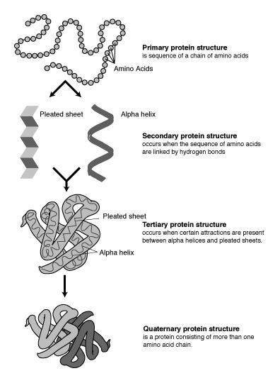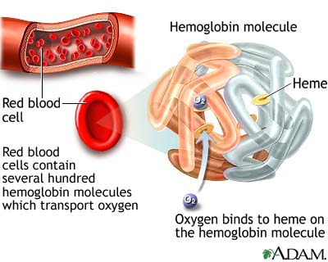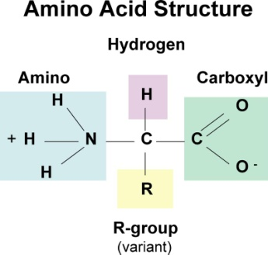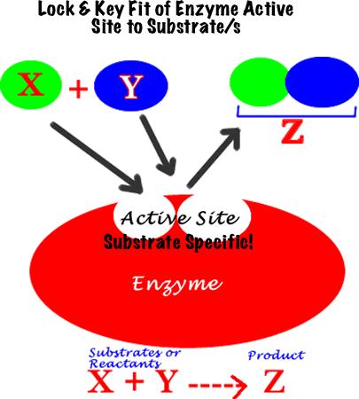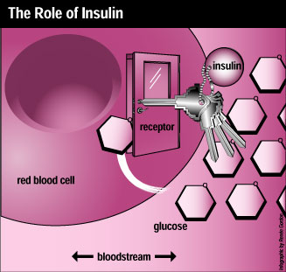

- What elements do they all have in common? _______________________
- Types/Examples:

Insulin Hemoglobin Enzymes Transport proteins

- _______________________________ - help transport substances across the plasma membrane
- _______________________________ - act as catalysts in chemical reactions
- _______________________________ - help to transport glucose from the bloodstream into red blood cells
- _______________________________ - bound to red blood cells in order to transport oxygen to cells around the body

4. Monomer unit: ____________________________

5. List several different functions of this molecule:
- _________________________________________________________________________
- _________________________________________________________________________
- _________________________________________________________________________
- _________________________________________________________________________
- _________________________________________________________________________

