**Re-Looping - Transport**

**Objective 3: Cell Transport and Homeostasis ((4.2.1/1.2.1)**

**The diagram below shows many proteins and other molecules embedded in a cell membrane. These molecules are flexible and able to move around within the membrane. Because of this, it is described as being a FLUID MOSAIC. The arrangement of the phospholipids into 2 distinct layers is what defines it as a PHOSPHOLIPID BILAYER.**

1. Label the proteins and phospholipids in the membrane below.
2. What is the function of the cell (plasma) membrane?
3. What is the function of the integral transport proteins (carrier proteins)?

[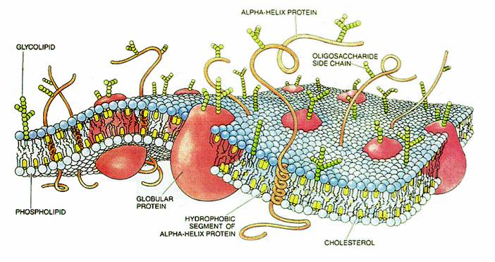](http://upload.wikimedia.org/wikipedia/commons/e/ee/CellMembraneDrawing.jpg)

**True or False Statements: For every FALSE statement, correct it to make it true.**

1. _________ Active transport requires energy ATP.
2. _________ Active transport uses energy to move molecules from an area of high concentration to an area of low concentration.
3. _________ Active transport moves molecules against their concentration gradient (uphill) using proteins.
4. _________ Diffusion is the passive movement of water molecules.
5. _________ Diffusion is the active movement of large molecules.
6. _________ An example of diffusion would be plants absorbing CO2 from the atmosphere.
7. _________ An example of diffusion would be roots of a plants absorbing nutrients from the soil.
8. _________An example of diffusion would be saltwater moving into the leaves of an Elodea plant.

**Diagram Questions**

1. 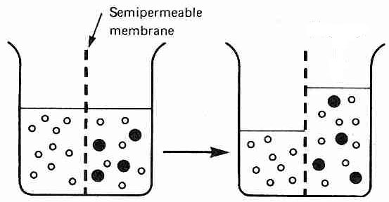Observe the diagram to the left showing the movement of some molecules across a semipermeable membrane. **Why did the large dark molecules NOT move to the left?**

3) If the dark molecule is starch, where is the starch concentration greatest (left or right)?

1. In **diffusion**, molecules move from an area of ________ to an area of ________ concentration.

5) If the large dark molecules could move, in what direction would they move? Why?

6) If the white molecule is water, where is the water concentration greatest at first (left or right side)? __________________________Then which way does the water move? This is called __________________.

7) In **osmosis**, water moves from an area of __________ to an area of _________ concentration.

7) Label the concentration of molecules inside and outside of each cell below as “**High**” or “**Low**”. Then label each cell below using the following terms: **Active transport**, **Passive Transport**.



8) Draw a diagram with arrows to show which way **solute (molecules)** will move in each of the following situations:

1. *Salt inside the cell = 65% and outside the cell 40%. b. Sugar inside the cell 27% and outside 80%.*

9) Draw a diagram with arrows to show which way **wate**r will move in each of the following situations:

*a. Sugar inside the cell = 65% and outside the cell 40%. b. Salt inside the cell 30% and outside 80%.*

***(this is just like a wilted lettuce leaf being placed in a bowl of (This is just like adding drops of saltwater onto an***

***fresh cold water!) Elodea leaf!)***

Will this cell shrink, swell, or stay the same? Will this cell shrink, swell, or stay the same?

10) **Comparison of active and passive transport**

|  |  |  |
| --- | --- | --- |
|  | **PASSIVE TRANPORT** | **ACTIVE TRANSPORT** |
| **Requires energy? (yes or no)** |  |  |
| **Low to high concentration**  **or**  **high to low concentration?** |  |  |

11) Draw a cell that has 8 molecules of CO2 outside and 4 molecules of CO2 inside. Label H and L concentrations. Explain how this cell would move CO2 molecules out of the cell, against its concentration gradient.