**Human Genetics**

TRAITS include “normal” characteristics as well as genetic **DISORDERS**

**What IS a pedigree?** ____________________________________________________________________________

**Example 1:** ___________________________

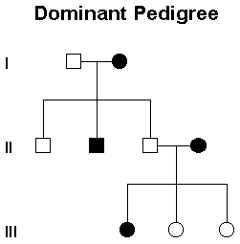

**Example 2:** ___________________________

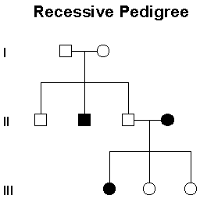

**Example 3:** ___________________________

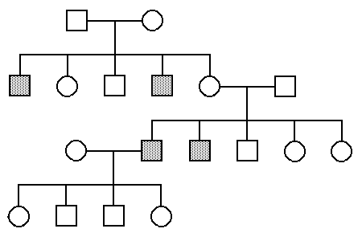

**Karyotype: ___________________________**

[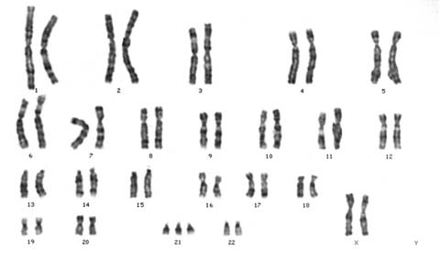](http://biochem.co/wp-content/uploads/2010/01/trisomy21female.jpg)

**Karyotype may show __________________ disorders / anueuploidy**

Autosomal aneuploidy:

Sex chromosome anueploidy:

**GENE DISORDERS:** Can NOT be seen on a karyotype!

|  |  |  |
| --- | --- | --- |
| **Disorder** | **Inheritance** | **Description** |
| Huntington’s disease |  |  |
| Sickle-cell anemia |  |  |
| Cystic Fibrosis |  |  |
| Tay-Sach’s |  |  |
| PKU |  |  |
| Hemophilia |  |  |
| Color-blindness |  |  |

**GENE Gene Therapy: __________________________**

**_____________________________________**